# Miniverse Puzzle Art Creative Brief

## Deadlines

January 31st. This isn’t a hard deadline at all, but I would hope to get the final piece by then. I’m not planning on releasing the game until quite later in the year, so the deadlines aren’t very harsh. Also this piece isn’t holding back any other work.

## Art Pieces

The piece of art I am looking for will be broken into 20 different puzzle pieces. Each piece being a piece of the puzzle. Essentially you’re creating the art and I’ll be breaking it apart into separate pieces of a puzzle. The shape of the whole art and the shape of each individual piece can be seen below.

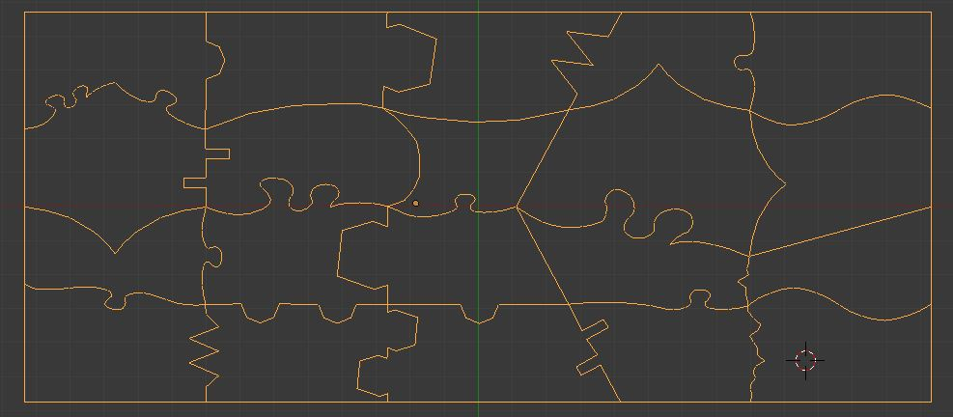

The artwork should generally fill the entire space. Since the artwork will be broken up into puzzle pieces there must be enough information on each piece to allow the player to recognize the connecting pieces.

## Art Style

The art should be of some sort of key in space. Maybe just a key floating around a space background, maybe a key flying around a planet, whatever floats your boat. For the game I try to stick to a cyberpunky, spacey steampunk style. I also try to give the game a lot of depth. The game takes place in space, so I want everything to feel deep and expansive. I’m thinking of an art piece along the same style. Each level the player beats they will get a piece of this puzzle, once they complete the puzzle they unlock the final boss level.

This is the level select screen where the puzzle will be assembled. On the lower half the screen the player can scroll through the levels, while on the upper half the player can assemble the puzzle (if it were there). While the art should fit within this general art theme / style it should still stick out from the background. If you use a spacey background, it should still standout from this spacey background.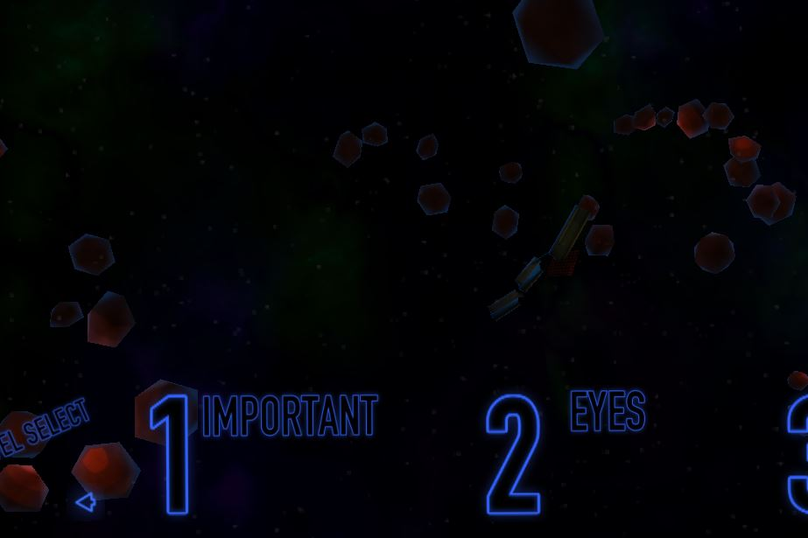

I use that blue neon glow for all UI elements, so each piece will be outlined using the exact same blue neon glow.

Below you can see the planet and ship used in the game. The give you an idea of the style used in the game. If you do decide to include a spaceship or planet in the art then they should resemble what they look like here. (I want all spaceships in the game to look the same and all planets in the game to look the same.)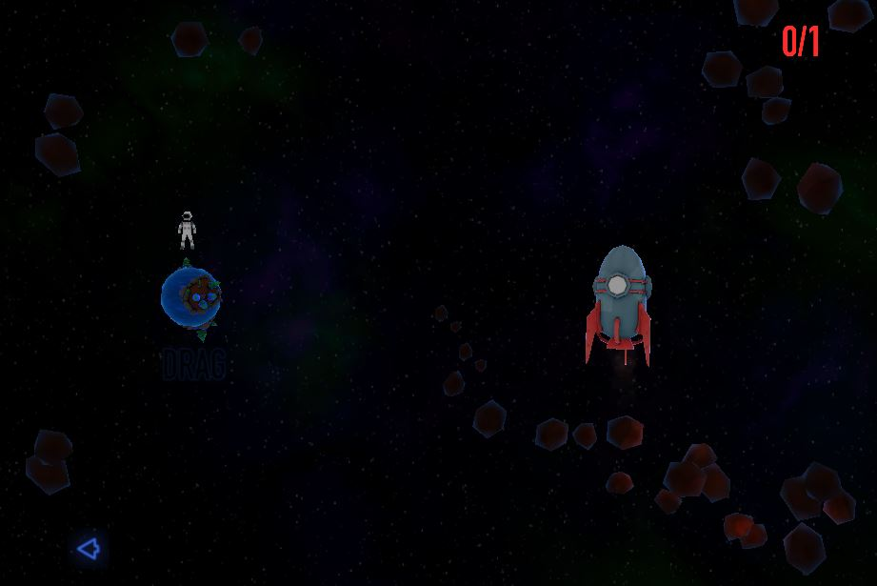

That’s about it! Let me know your thoughts.